ANSWERS.

1. Basic difference between Client and P2P server is that the client server model has a dedicated server and specific clients where the server gives services to the client. Here, information sharing is important allowing data to be stored on a centralized server while peer-to-peer servers allows each node to act as both server and client meaning that services can be provided and requested with each pair storing its own data.
2. The application layer enables each user to send files through a network to other users. It allows user to communicate to the network’s services. It also provides services facilitating user login, emails, network naming, file transfer etc. It could also help with error handling and message recovery.
3. In Data Encapsulation, some extra information is added to a packet or few features added to it to increase the information complexity that would prevent leak before it getting to destination.
4. Packet delays in a network can be caused due to large buffer sizes or ultimately buffer retention exceeding limits and a few reasons for data loss during transmissions includes interferences which could be caused by man or nature, unstable signal strength or corrupted software.
5. a. Confidentiality – This property ensure that information is only accessible by authorized personnel

b. Integrity – This ensures that information can only be modified by those authorized with the right level of permission.

c. Availability – This explains information being available at the right time to the right people. This is to ensure that malicious users don’t hinder access

d. Non Repudiation - This properties ensures that the source of an information can be traced, that is, a user cannot deny sending or receiving an information. This prevents tampering and replay attacks.

e. Authenticity is important to make sure that information are from a trusted source. This is to dissociate between fake and original information and a means to ensure this is Biometrics and Cryptography.

PRACTICAL

1. Answer - HTTP Version 1.1  
   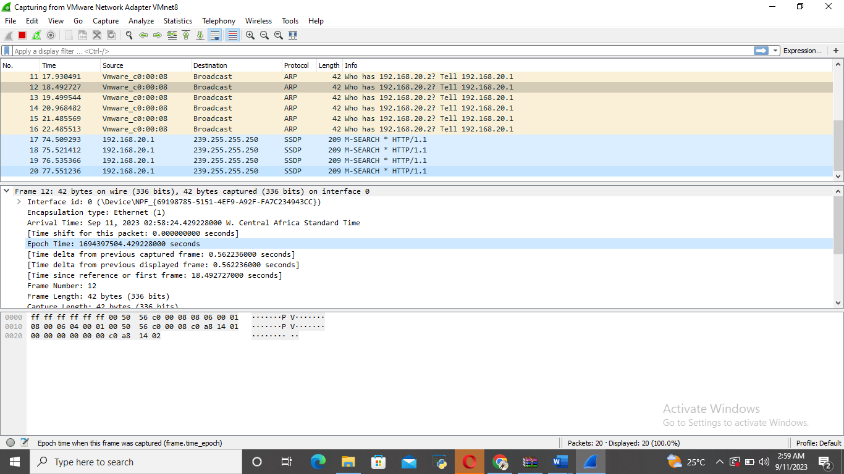
2. IP address of the client – 239.255.255.250

gaia.cs.umass.edu server – 192.168.20.1

1. Status code – 143

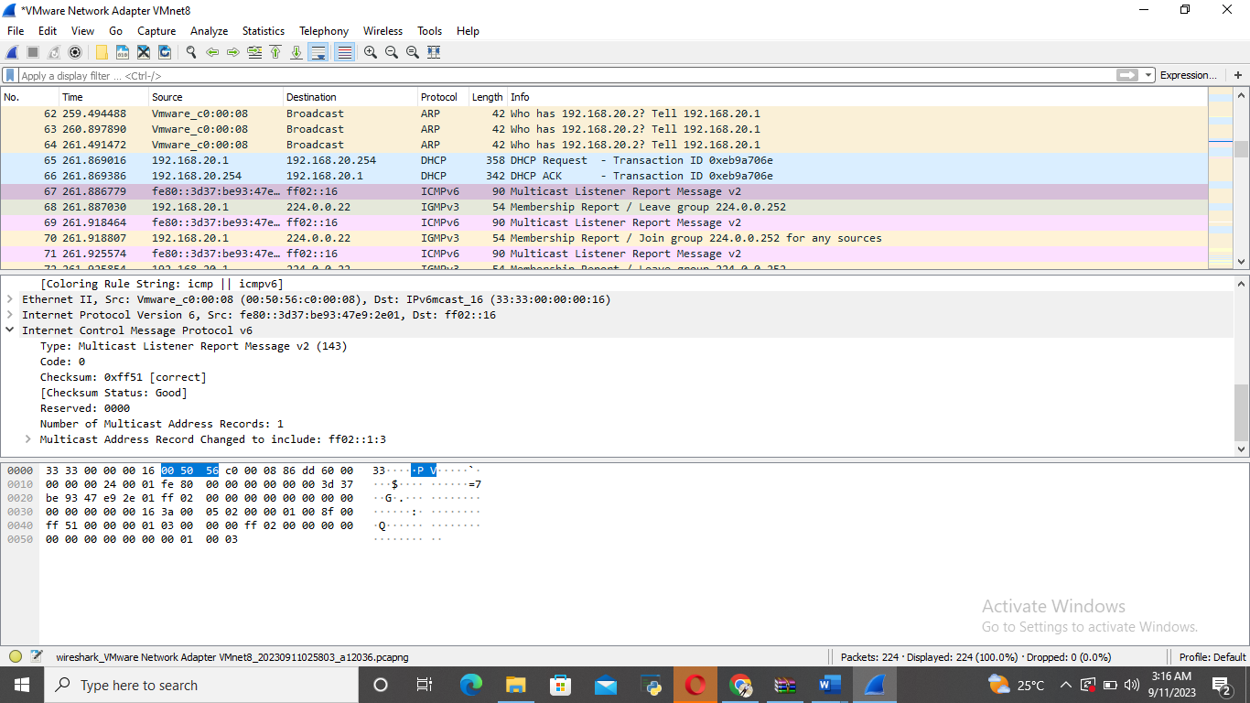

1. 1.01 Seconds

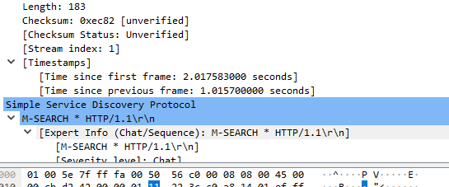

1. Destination port - 1900  
     
   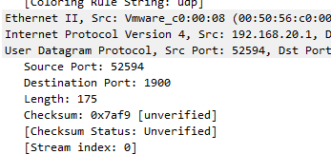
2. Source port - 52594